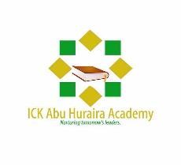
ICK Abu Huraira Academy

Circle Program Interested | Time
- Weekend | Sat & Sun 11 AM – 2PM
- Weekday- Session I | Mon – Thur 4:30 - 6:00 PM
- Weekday- Session 2 | Mon – Thur 6:00 – 7:30 Pm

Details of the students

Full name (s) | Gender: | Age:

Details of the Parents/Guardian of the student

Full name

Address:

Contact No.
Email

Please give details of any medical condition of the student:

Course fees

  - Weekday $50/Student
  - Weekend $60/Student
Terms & Conditions

I confirm I have read the terms and conditions of the Weekend Islamic School as stated with the application form.

Signature of Parent/Guardian:

Date:

Terms and conditions of ICK Abu Huraira Academy

The aim of the Leeds Weekend Islamic School is to provide the students with secure and safe Islamic learning environment. However, in the event of unforeseen circumstances, the teachers, volunteers, staff and the center bears absolutely no legal responsibility of any kind.

Students can be expelled due to their misconduct and bad behaviour.

Students must bring their own stationary and notebook.

Students must ensure they leave the classroom tidy and clean. No food will be consumed in the classroom.

Students must ensure the premises is not damaged.

Students must behave with respect with other students, teachers and other staff.

It is the duty of the parents/guardians to ensure their children arrive on time.

It is the duty of the parents/guardians to arrange transport for their children.

Parents/guardians must ensure they arrive on time to pick up their children.

